

W6 PRACTICE
FORMS & INPUTS

Name: THANG SAOLY
Student’s ID: IDTB110257
Group: 03
Subject: Web Design
Department: Computer Science



PART 1: LEARN – 45 MIN

- Read or watch resources on internet to learn about HTML Inputs:
Guide - WC3 School
The Form element
HTML Forms

- Complete the bellow table.

INPUT TYPE | USAGE | EXAMPLE
Text | defines a one-line input field for text input | <input type="text">
radio | defines a radio button (for selecting one of many choices) | <input type="radio" name="gender" value="male">
checkbox | defines a checkbox (for selecting zero or more of many choices) | <input type="checkbox" name="vehicle1" value="Bike">
range | defines a control for entering a number whose exact value is not important (usually rendered as a slider) | <input type="range" min="0" max="100">
submit | defines a button for submitting the form data to a form-handler | <input type="submit" value="Send">
textarea | defines a multi-line text input control (a field for larger blocks of text) | <textarea name="comment" rows="4" cols="50"></textarea>
select | defines a drop-down list for selecting one or more options | <select name="cars"></select>
color | defines a color picker | <input type="color" value="#ff0000">
file | defines a file-select field and a "Browse" button for file uploads | <input type="file" name="myFile">

- Read or watch resources on internet to learn about Inputs styling:
https://www.w3schools.com/css/css_form.asp
- Complete those mini challenges by writing your code on bellow table:

MINI CHALLENGES | YOUR CODE (HTML + CSS)
Highlight the input field when it is focused | <!DOCTYPE html>  <html lang="en">  <head>  <meta charset="UTF-8">  <meta name="viewport" content="width=device-width, initial-scale=1.0">  <title>Document</title>  <style>  input[type="text"]:focus,  textarea:focus {  border-color: #007bff;  box-shadow: 0 0 5px rgba(0, 123, 255, 0.6);  outline: 2px solid #ffaa00;  outline-offset: 2px;  }  </style>  </head>  <body>  <div class="sign-up">  <h2> Highlight the input field when it is focused</h2>  <form action="">  <label for="fname">First Name:</label><br>  <input type="text" id="fname" name="fname"><br>  <label for="lname">Last Name:</label><br>  <input type="text" id="lname" name="lname"><br>  </form>  </div>  </body>  </html>
Change the button background color on hover | <!DOCTYPE html>  <html lang="en">  <head>  <meta charset="UTF-8">  <meta name="viewport" content="width=device-width, initial-scale=1.0">  <title>Document</title>  <style>  button {  background-color: lightgreen;  padding: 10px 20px;  border: none;  border-radius: 5px;  cursor: pointer;  }  button:hover {  background-color: darkgreen;  color: white;  }  </style>  </head>  <body>  <div class="sign-up">  <h2>Change the button background color on hover </h2>  <button>Hover me</button>  </div>  </body>  </html>
Create a search bar with rounded corners and a shadow effect | <!DOCTYPE html>  <html lang="en">  <head>  <meta charset="UTF-8">  <title>Search Bar</title>  <style>  .search-container {  width: 300px;  margin: 50px auto;  }  .search-input {  width: 100%;  padding: 10px 15px;  border: 1px solid #ccc;  border-radius: 25px;  box-shadow: 0 4px 8px rgba(0, 0, 0, 0.1);  font-size: 16px;  box-sizing: border-box;  transition: box-shadow 0.3s ease-in-out;  }  .search-input:focus {  outline: none;  border-color: #007bff;  box-shadow: 0 6px 12px rgba(0, 0, 0, 0.15);  }  </style>  </head>  <body>  <div class="search-container">  <h2>A search bar with rounded corners and a shadow effect </h2>  <input type="search" class="search-input" placeholder="Search...">  </div>  </body>  </html>
Display a different style when the checkbox is checked | <!DOCTYPE html>  <html lang="en">  <head>  <meta charset="UTF-8">  <title>ok</title>  <style>  label {  display: inline-block;  padding: 10px 15px;  background-color: #f0f0f0;  border: 1px solid #ccc;  border-radius: 5px;  cursor: pointer;  transition: background-color 0.3s;  }  input[type="checkbox"]:checked + label {  background-color: #4CAF50;  color: white;  border-color: #388E3C;  font-weight: bold;  box-shadow: 0 4px 6px rgba(0, 0, 0, 0.1);  }  input[type="checkbox"] {  display: none;  }  </style>  </head>  <body>  <input type="checkbox" id="styleToggle">  <label for="styleToggle">  Check this box to change my style!  </label>  </body>  </html>
HARD!  Style a checkbox to have three states: unchecked, checked, and indeterminate.  TIP  Use CSS pseudo-classes  (:checked and :indeterminate) for styling. | <!DOCTYPE html>  <html lang="en">  <head>  <meta charset="utf-8">  <title>Three-state checkbox</title>  <style>  #threeStateCheckbox {  position: absolute;  opacity: 0;  left: -9999px;  }  label {  position: relative;  display: inline-flex;  align-items: center;  cursor: pointer;  user-select: none;  }  label::before {  content: '';  display: block;  width: 20px;  height: 20px;  margin-right: 10px;  border: 2px solid #555;  border-radius: 4px;  background: #fff;  transition: all .15s;  }  #threeStateCheckbox:checked+label::before {  background: #4CAF50;  border-color: #4CAF50;  }  #threeStateCheckbox:checked+label::after {  content: '';  position: absolute;  left: 6px;  top: 6px;  width: 6px;  height: 10px;  border: solid #fff;  border-width: 0 3px 3px 0;  transform: rotate(45deg);  }  #threeStateCheckbox:indeterminate+label::before {  background: #FFA500;  border-color: #FFA500;  }  #threeStateCheckbox:indeterminate+label::after {  content: '';  position: absolute;  left: 5px;  top: 13px;  width: 12px;  height: 0;  border-top: 4px solid #fff;  }  </style>  </head>  <body>  <input id="threeStateCheckbox" type="checkbox" aria-checked="false">  <label for="threeStateCheckbox">Group Selection</label>  <script>  const cb = document.getElementById('threeStateCheckbox');  const lbl = document.querySelector('label[for="threeStateCheckbox"]');  let state = 0; // 0 = unchecked, 1 = checked, 2 = indeterminate  function applyState(s) {  cb.checked = s === 1;  cb.indeterminate = s === 2;  cb.setAttribute('aria-checked', s === 2 ? 'mixed' : (s === 1 ? 'true' : 'false'));  }  applyState(state);  lbl.addEventListener('click', e => {  e.preventDefault();  state = (state + 1) % 3;  applyState(state);  cb.focus();  });  cb.addEventListener('keydown', e => {  if (e.key === ' ' || e.key === 'Spacebar') {  e.preventDefault();  lbl.click();  }  });  </script>  </body>  </html>

- Some groups will be selected to present and explain their work to the whole class

PART 2: PRACTICE – 45 MIN

You need to reproduce – as close as possible - the bellow table.

Before coding, identify the following point:

- Elements: What are the different inputs you will need?

- Layout: what kind of CSS layout do you need? Why?

- Input styling: What are the styles you need to apply on your inputs?

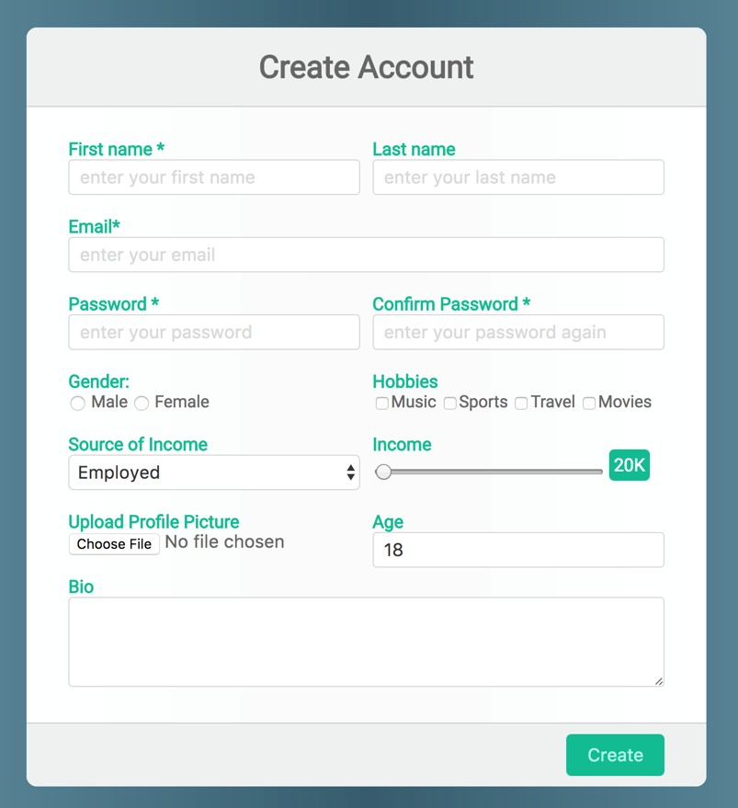

Be as close as possible from this mock up

My code: https://github.com/thangsaoly/w6-practice-forms.git

